**QUESTION 1:**

### DESCRIBE THE STEPS TO DOWNLOAD AND INSTALL VISUAL STUDIO CODE ON WINDOWS 11 OPERATING SYSTEM. INCLUDE ANY PREREQUISITES THAT MIGHT BE NEEDED.

**ANSWER**:

**Step-by-Step Guide to Download and Install Visual Studio Code on Windows 11**

1. **Open Your Web Browser:** Launch your preferred web browser (e.g., Microsoft Edge, Google Chrome, Mozilla Firefox).
2. **Navigate to the Visual Studio Code Website:** Go to the official Visual Studio Code website by typing https://code.visualstudio.com/ into the address bar and pressing Enter.
3. **Download Visual Studio Code:** On the Visual Studio Code homepage, you will see a download button. It usually detects your operating system automatically. Click on the download button for Windows. If it doesn’t automatically detect your OS, click on the “Download for Windows” link.
4. **Run the Installer:** Once the download is complete, open the downloaded file (usually named something like VSCodeSetup.exe). You may see a security warning asking if you want to run this file. Click “Run.”

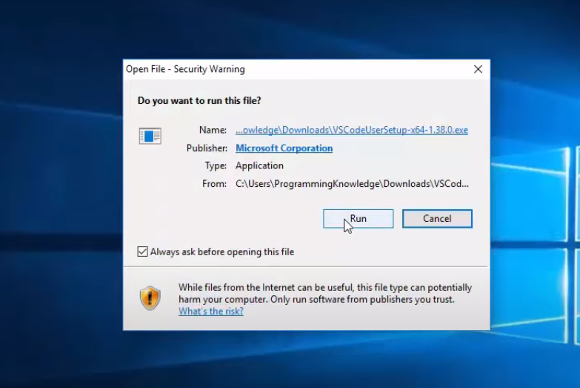

1. **Start the Installation Process:** The Visual Studio Code Setup Wizard will open. Click “Next” to start the installation process.

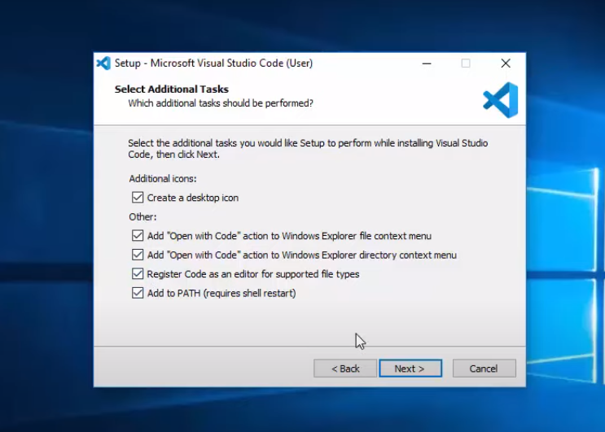

1. **Accept the License Agreement:** Read through the license agreement. If you accept the terms, check the box that says “I accept the agreement” and click “Next.”
2. **Select Installation Location:** Choose the destination folder where you want Visual Studio Code to be installed. The default location is usually fine, so you can click “Next.”
3. **Select Additional Tasks:** You can choose to create a desktop icon and add other options such as “Open with Code” actions in the Windows Explorer context menu. Select the options you prefer and click “Next.”
4. **Install Visual Studio Code:** Click “Install” to begin the installation process. This might take a few minutes.
5. **Complete the Installation:** Once the installation is complete, you’ll see a confirmation screen. You can choose to launch Visual Studio Code immediately by checking the box that says “Launch Visual Studio Code” and then click “Finish.”

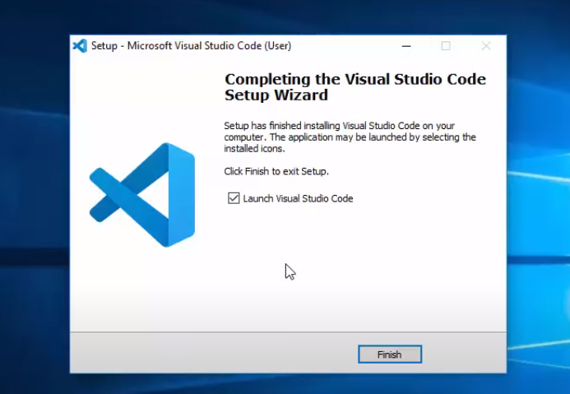

**QUESTION 2:**

### AFTER INSTALLING VS CODE, WHAT INITIAL CONFIGURATIONS AND SETTINGS SHOULD BE ADJUSTED FOR AN OPTIMAL CODING ENVIRONMENT? MENTION ANY IMPORTANT SETTINGS OR EXTENSIONS.

**ANSWER**:

**VS Code Initial Configurations And Settings For An Optimal Coding Environment**

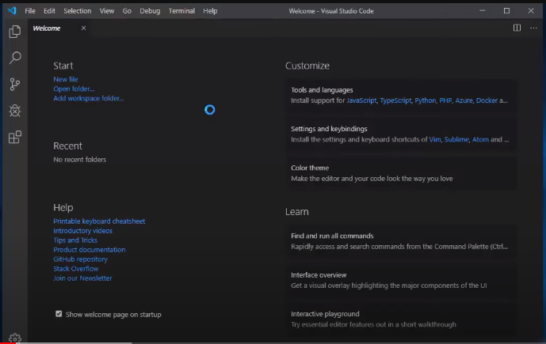

**Initial Configurations and Settings**

1. **User and Workspace Settings:**
   * Open the Command Palette by pressing Ctrl+Shift+P and type "Preferences: Open Settings (UI)".
   * Configure settings such as font size, theme, tab size, and other editor preferences.
2. **Select a Theme:**
   * Go to File > Preferences > Color Theme or press Ctrl+K Ctrl+T.
   * Choose a theme that is easy on your eyes. Popular themes include "Dark+" and "Monokai".
3. **Configure Font and Font Size:**
   * In the Settings UI, search for Font and set the Editor: Font Family and Editor: Font Size to your preference.
4. **Enable Auto Save:**
   * In the Settings UI, search for Auto Save and set it to afterDelay or onWindowChange based on your preference.
5. **Adjust Tab and Indentation Settings:**
   * Search for Tab Size and Indentation settings in the Settings UI and configure them according to your coding style. Typically, Tab Size is set to 2 or 4 spaces.

**Important Extensions**

1. **Python (ms-python.python):**
   * If you are working with Python, this extension provides rich support including linting, debugging, and IntelliSense.
2. **ESLint (dbaeumer.vscode-eslint):**
   * For JavaScript/TypeScript development, this extension integrates ESLint into VS Code.
3. **Prettier - Code Formatter (esbenp.prettier-vscode):**
   * Automatically format your code on save to maintain consistency and readability.
4. **Live Server (ritwickdey.LiveServer):**
   * For web development, this extension launches a local development server with live reload feature for static and dynamic pages.
5. **GitLens (eamodio.gitlens):**
   * Enhances the Git capabilities of VS Code with powerful features such as visualizing code authorship, repository exploration, and more.
6. **Bracket Pair Colorizer (CoenraadS.bracket-pair-colorizer-2):**
   * Colorizes matching brackets to make it easier to understand nested code structures.
7. **IntelliCode (VisualStudioExptTeam.vscodeintellicode):**
   * Provides AI-assisted IntelliSense suggestions based on best practices learned from thousands of open-source projects.
8. **Debugger for Chrome (msjsdiag.debugger-for-chrome):**
   * Allows you to debug JavaScript code running in Google Chrome directly from VS Code.
9. **Docker (ms-azuretools.vscode-docker):**
   * Adds support for Docker, making it easier to build, manage, and deploy containerized applications.
10. **Remote - WSL (ms-vscode-remote.remote-wsl):**
    * For Windows users working with the Windows Subsystem for Linux, this extension allows you to use WSL as your development environment.

**Additional Settings**

1. **Configure Version Control:**
   * Set up Git integration by going to View > Source Control or pressing Ctrl+Shift+G.
   * Configure your user name and email in the Git settings: git config --global user.name "Your Name" and git config --global user.email "your.email@example.com".
2. **Set Up Integrated Terminal:**
   * Go to File > Preferences > Settings and search for Terminal.
   * Configure the default shell for the integrated terminal (e.g., Command Prompt, PowerShell, Git Bash).
3. **Install Language Packs:**
   * If you work with multiple languages, install the necessary language packs and extensions for syntax highlighting and IntelliSense.
4. **Enable Format on Save:**
   * In the Settings UI, search for Format On Save and enable it. This ensures your code is automatically formatted whenever you save a file.
5. **Configure Snippets:**
   * Customize or create your own code snippets for repetitive code patterns. Go to File > Preferences > User Snippets and select the language for which you want to create snippets.

**QUESTION 3:**

### EXPLAIN THE MAIN COMPONENTS OF THE VS CODE USER INTERFACE. IDENTIFY AND DESCRIBE THE PURPOSE OF THE ACTIVITY BAR, SIDE BAR, EDITOR GROUP, AND STATUS BAR.

**ANSWER**:

**Main Components of the VS Code User Interface**

1. **Activity Bar:**
   * **Location:** Vertically along the left side of the window.
   * **Purpose:** Provides quick access to different views and features within VS Code. The Activity Bar contains icons for:
     + **Explorer:** Access your files and folders.
     + **Search:** Perform searches across your files.
     + **Source Control:** Manage version control (e.g., Git).
     + **Run and Debug:** Control debugging sessions.
     + **Extensions:** Browse and install extensions to add functionality.
   * **Customization:** You can add or remove icons, and rearrange them by dragging.
2. **Side Bar:**
   * **Location:** To the right of the Activity Bar.
   * **Purpose:** Displays different views and tools depending on the selected activity from the Activity Bar. For example:
     + **Explorer:** Shows a tree view of your project files and folders.
     + **Search:** Provides search results and search options.
     + **Source Control:** Displays changes, commits, and branch management options.
     + **Run and Debug:** Shows debugging controls, breakpoints, and variables.
     + **Extensions:** Lists installed extensions and available ones from the marketplace.
   * **Customization:** You can resize the Side Bar by dragging its border.
3. **Editor Group:**
   * **Location:** The central area of the window, where you write and edit your code.
   * **Purpose:** The main area where code files and other resources are opened. You can open multiple files in tabs within an Editor Group, and you can have multiple Editor Groups open at the same time (split view).
   * **Features:**
     + **Tabs:** Each open file is represented by a tab.
     + **Split Editor:** You can split the editor into multiple groups to view and edit files side by side.
     + **Minimap:** A small overview of the entire file for quick navigation.
   * **Customization:** You can change the layout and behavior of Editor Groups via settings and extensions.
4. **Status Bar:**
   * **Location:** Horizontally along the bottom of the window.
   * **Purpose:** Provides information and status updates about your project and editor. Key elements include:
     + **Language Mode:** Displays the current file’s language (e.g., JavaScript, Python).
     + **Encoding:** Shows the file encoding (e.g., UTF-8).
     + **Line and Column:** Indicates the current cursor position in the file.
     + **Notifications:** Displays notifications and messages from extensions and the system.
     + **Branch and Repository Status:** Shows the current Git branch and repository status if version control is used.
   * **Customization:** You can click on various parts of the Status Bar to change settings (e.g., change language mode, encoding).

**QUESTION 4:**

### WHAT IS THE COMMAND PALETTE IN VS CODE, AND HOW CAN IT BE ACCESSED? PROVIDE EXAMPLES OF COMMON TASKS THAT CAN BE PERFORMED USING THE COMMAND PALETTE.

**ANSWER**:

**Accessing the Command Palette**

You can open the Command Palette in VS Code in two primary ways:

1. **Using Keyboard Shortcuts:**
   * Press Ctrl+Shift+P (or Cmd+Shift+P on macOS) to open the Command Palette.
2. **Using the Menu:**
   * Go to View > Command Palette from the top menu bar.

**Examples of Common Tasks Using the Command Palette**

Here are some examples of common tasks you can perform using the Command Palette:

1. **Opening and Closing Files:**
   * **Open File:** Type Open File and select the file you want to open.
   * **Close File:** Type Close Editor to close the current file.
2. **Running and Debugging Code:**
   * **Start Debugging:** Type Debug: Start Debugging to start a debugging session.
   * **Run Task:** Type Tasks: Run Task to execute a predefined task.
3. **Managing Extensions:**
   * **Install Extension:** Type Extensions: Install Extensions to browse and install new extensions.
   * **Disable Extension:** Type Extensions: Disable Extension to disable an installed extension.
4. **Version Control:**
   * **Commit Changes:** Type Git: Commit to commit changes to your repository.
   * **Push to Remote:** Type Git: Push to push your commits to a remote repository.
5. **Customization and Settings:**
   * **Change Color Theme:** Type Preferences: Color Theme to change the editor's color theme.
   * **Open Settings:** Type Preferences: Open Settings (UI) to open the settings editor.
6. **Searching and Navigating:**
   * **Find in Files:** Type Search: Find in Files to search across all files in your workspace.
   * **Go to Line:** Type Go to Line to navigate to a specific line number in the current file.
7. **Snippet Insertion:**
   * **Insert Snippet:** Type Insert Snippet to insert a code snippet from your snippet library.
8. **View and Editor Management:**
   * **Toggle Terminal:** Type View: Toggle Integrated Terminal to open or close the integrated terminal.
   * **Split Editor:** Type View: Split Editor to split the current editor into multiple views.
9. **Working with Specific Languages and Tools:**
   * **Format Document:** Type Format Document to format the entire document according to the language and formatting settings.
   * **Run Code:** If you have an extension like Code Runner, you can type Run Code to execute the current file.

**QUESTION 5:**

### DISCUSS THE ROLE OF EXTENSIONS IN VS CODE. HOW CAN USERS FIND, INSTALL, AND MANAGE EXTENSIONS? PROVIDE EXAMPLES OF ESSENTIAL EXTENSIONS FOR WEB DEVELOPMENT.

**ANSWER**:

**Finding, Installing, and Managing Extensions**

1. **Finding Extensions:**
   * **Extensions View:**
     + Open the Extensions view by clicking the Extensions icon in the Activity Bar on the side of the window or by pressing Ctrl+Shift+X (or Cmd+Shift+X on macOS).
     + Use the search bar to find extensions by name, category, or keyword.
   * **VS Code Marketplace:**
     + Visit the [Visual Studio Code Marketplace](https://marketplace.visualstudio.com/VSCode) to browse and discover popular extensions.
2. **Installing Extensions:**
   * **From the Extensions View:**
     + Once you find an extension you want to install, click the “Install” button next to the extension’s name.
   * **From the Marketplace:**
     + Click on the extension, and you will be redirected to its details page. Click “Install” to add it to your VS Code.
3. **Managing Extensions:**
   * **View Installed Extensions:**
     + In the Extensions view, click on the “Installed” tab to see a list of all installed extensions.
   * **Enable/Disable Extensions:**
     + Click the gear icon next to an installed extension and select “Enable” or “Disable”.
   * **Uninstall Extensions:**
     + Click the gear icon next to an installed extension and select “Uninstall”.
   * **Update Extensions:**
     + If updates are available, you will see a notification in the Extensions view. Click “Update” to apply the latest version.

**Essential Extensions for Web Development**

1. **HTML, CSS, and JavaScript:**
   * **HTML Snippets (abusaidm.html-snippets):** Provides a large number of HTML snippets to speed up coding.
   * **CSS Peek (pranaygp.vscode-css-peek):** Allows you to peek at CSS definitions directly from your HTML files.
   * **JavaScript (ES6) code snippets (xabikos.javascriptsnippets):** Adds ES6 JavaScript code snippets.
2. **Code Formatting and Linting:**
   * **Prettier - Code Formatter (esbenp.prettier-vscode):** Automatically formats your code according to a consistent style.
   * **ESLint (dbaeumer.vscode-eslint):** Integrates ESLint into VS Code to provide linting and error-checking for JavaScript and TypeScript.
3. **Version Control:**
   * **GitLens (eamodio.gitlens):** Enhances Git capabilities with visualizations and powerful features like code authorship and repository exploration.
   * **Git History (donjayamanne.githistory):** Allows you to view and search Git log history.
4. **Live Server:**
   * **Live Server (ritwickdey.LiveServer):** Launches a local development server with live reload feature for static and dynamic pages.
5. **Browser Integration:**
   * **Debugger for Chrome (msjsdiag.debugger-for-chrome):** Debug JavaScript code running in Google Chrome directly from VS Code.
6. **Frameworks and Libraries:**
   * **Vue.js Extension Pack (mubaidr.vuejs-extension-pack):** A collection of extensions for Vue.js development.
   * **React Native Tools (msjsdiag.vscode-react-native):** Provides tools for developing and debugging React Native applications.
   * **Angular Essentials (johnpapa.angular-essentials):** A collection of extensions for Angular development.
7. **Utilities:**
   * **Path Intellisense (christian-kohler.path-intellisense):** Autocompletes file paths in your code.
   * **REST Client (humao.rest-client):** Allows you to send HTTP requests and view responses directly in VS Code.
8. **Container and Cloud Integration:**
   * **Docker (ms-azuretools.vscode-docker):** Adds support for Docker, including container management and Dockerfile IntelliSense.
   * **Azure Tools (ms-vscode.vscode-azureextensionpack):** A pack of extensions for deploying and managing applications on Azure.

**QUESTION 6:**

### DESCRIBE HOW TO OPEN AND USE THE INTEGRATED TERMINAL IN VS CODE. WHAT ARE THE ADVANTAGES OF USING THE INTEGRATED TERMINAL COMPARED TO AN EXTERNAL TERMINAL?

**ANSWER**:

### Opening and Using the Integrated Terminal in VS Code

#### **Opening the Integrated Terminal**

1. **Using the Menu:**
   * Navigate to the top menu bar and select View > Terminal.
2. **Using Keyboard Shortcuts:**
   * Press Ctrl+ (or Cmd+ on macOS) to open the integrated terminal.
3. **Using the Command Palette:**
   * Open the Command Palette by pressing Ctrl+Shift+P (or Cmd+Shift+P on macOS), then type Terminal: Create New Integrated Terminal and press Enter.

#### **Using the Integrated Terminal**

1. **Basic Terminal Operations:**
   * Once the terminal is open, you can use it just like any other terminal window to run commands, scripts, and interact with your development environment.
2. **Creating Multiple Terminals:**
   * Click the + icon in the terminal panel to open a new terminal tab.
   * You can switch between different terminal sessions by clicking on the tabs.
3. **Splitting Terminals:**
   * Click the split terminal icon (which looks like a window split vertically) to split the terminal pane and run different sessions side by side.
4. **Selecting the Default Shell:**
   * To change the default shell, go to File > Preferences > Settings (or press Ctrl+,), search for terminal.integrated.shell.windows (or .shell.linux / .shell.osx depending on your OS), and set it to your preferred shell (e.g., PowerShell, Command Prompt, Git Bash, or any other shell).
5. **Configuring Terminal Settings:**
   * Customize terminal settings like font size, cursor style, and theme by going to File > Preferences > Settings and searching for terminal.integrated.
6. **Running Tasks:**
   * You can run predefined tasks by using the Command Palette and searching for Tasks: Run Task. This is particularly useful for running build scripts, tests, and other automated tasks.

### Advantages of Using the Integrated Terminal

1. **Seamless Workflow:**
   * The integrated terminal allows you to stay within the VS Code environment, reducing the need to switch between different applications. This seamless integration enhances productivity by providing a unified workspace.
2. **Context Awareness:**
   * The integrated terminal automatically opens in the workspace folder, making it easier to run commands relative to your project directory without additional navigation.
3. **Visibility and Accessibility:**
   * The terminal is easily accessible from within VS Code, allowing you to view and interact with terminal output while simultaneously editing your code. This can be especially useful for debugging and testing.
4. **Synchronization with Editor:**
   * The terminal can be synchronized with the editor, providing features like automatic terminal directory updates based on the currently open file’s directory. This ensures commands are executed in the correct context.
5. **Customizable Appearance:**
   * You can customize the terminal’s appearance to match your coding environment, adjusting settings like font size, colors, and cursor style for better readability and comfort.
6. **Integrated Features:**
   * The integrated terminal supports features like running tasks, interacting with version control (e.g., Git commands), and even debugging directly within VS Code, enhancing the overall development experience.
7. **Multiple Terminals:**
   * You can open multiple terminal sessions and split terminals within VS Code, making it easier to manage different tasks simultaneously, such as running a server, monitoring logs, and executing commands.
8. **Extension Support:**
   * Extensions can enhance the functionality of the integrated terminal, providing additional features like improved command-line tools, terminal enhancements, and better integration with other development tools.

**QUESTION 7:**

### EXPLAIN HOW TO CREATE, OPEN, AND MANAGE FILES AND FOLDERS IN VS CODE. HOW CAN USERS NAVIGATE BETWEEN DIFFERENT FILES AND DIRECTORIES EFFICIENTLY?

**ANSWER**:

**Creating Files and Folders**

1. **Creating a New File:**
   * **Using the Explorer:**
     + Open the Explorer view by clicking the Explorer icon in the Activity Bar or pressing Ctrl+Shift+E.
     + Right-click on the folder where you want to create the new file and select New File.
     + Enter the name of the new file and press Enter.
   * **Using the Command Palette:**
     + Press Ctrl+Shift+P to open the Command Palette.
     + Type File: New File and press Enter.
     + Save the new file by pressing Ctrl+S, and then specify the location and name.
2. **Creating a New Folder:**
   * **Using the Explorer:**
     + Open the Explorer view.
     + Right-click on the parent folder where you want to create the new folder and select New Folder.
     + Enter the name of the new folder and press Enter.

**Opening Files and Folders**

1. **Opening an Existing File:**
   * **Using the Explorer:**
     + Navigate through the directory tree in the Explorer view and double-click the file you want to open.
   * **Using the Command Palette:**
     + Press Ctrl+P to open the Quick Open dialog.
     + Start typing the name of the file and select it from the list.
   * **Using the Menu:**
     + Go to File > Open File and navigate to the file you want to open.
2. **Opening an Existing Folder:**
   * **Using the Menu:**
     + Go to File > Open Folder and navigate to the folder you want to open.
   * **Using the Explorer:**
     + In the Explorer view, click on the Open Folder button if no folder is currently open.

**Managing Files and Folders**

1. **Renaming Files and Folders:**
   * **Using the Explorer:**
     + Right-click on the file or folder you want to rename and select Rename.
     + Enter the new name and press Enter.
2. **Deleting Files and Folders:**
   * **Using the Explorer:**
     + Right-click on the file or folder you want to delete and select Delete.
     + Confirm the deletion if prompted.
3. **Moving Files and Folders:**
   * **Using Drag and Drop:**
     + Drag the file or folder from its current location in the Explorer and drop it into the desired destination.
   * **Using Cut and Paste:**
     + Right-click on the file or folder, select Cut, then right-click on the destination folder and select Paste.

**Navigating Between Files and Directories Efficiently**

1. **Using the Explorer:**
   * The Explorer view provides a tree view of your workspace. You can collapse and expand directories to quickly navigate to the desired files.
2. **Using Quick Open:**
   * Press Ctrl+P to open the Quick Open dialog.
   * Start typing the name of the file, and it will provide a list of matching files in your workspace. Select the file you want to open.
3. **Using the Command Palette:**
   * Press Ctrl+Shift+P to open the Command Palette.
   * Type commands like File: Open Recent to quickly access recently opened files.
4. **Using Go to Definition and Go to Symbol:**
   * **Go to Definition:**
     + Right-click on a symbol in your code and select Go to Definition or press F12. This will navigate to the definition of the symbol.
   * **Go to Symbol:**
     + Press Ctrl+Shift+O to open the Go to Symbol dialog, which lists all symbols in the current file. Type the symbol name to quickly navigate to it.
5. **Using Breadcrumbs:**
   * Breadcrumbs show the current location and allow you to quickly navigate to parent symbols and files.
   * Enable breadcrumbs by going to View > Appearance > Show Breadcrumbs.
6. **Using Tabs and Split Views:**
   * Open multiple files in tabs and switch between them by clicking the tab or pressing Ctrl+Tab.
   * Split the editor to view multiple files side by side by right-clicking on a tab and selecting Split Right or Split Down.
7. **Using the Integrated Terminal:**
   * Navigate your project directory using the integrated terminal. You can open files from the terminal by typing commands like code filename.

**QUESTION 8:**

### WHERE CAN USERS FIND AND CUSTOMIZE SETTINGS IN VS CODE? PROVIDE EXAMPLES OF HOW TO CHANGE THE THEME, FONT SIZE, AND KEYBINDINGS.

**ANSWER**:

**Accessing And Customizing Settings in VS Code**

1. **Using the Menu:**
   * Go to File > Preferences > Settings (or Code > Preferences > Settings on macOS).
2. **Using Keyboard Shortcuts:**
   * Press Ctrl+, (or Cmd+, on macOS).
3. **Using the Command Palette:**
   * Press Ctrl+Shift+P (or Cmd+Shift+P on macOS) to open the Command Palette.
   * Type Preferences: Open Settings and press Enter.

**Changing the Theme**

1. **Open the Command Palette:**
   * Press Ctrl+Shift+P (or Cmd+Shift+P on macOS) to open the Command Palette.
2. **Select Theme:**
   * Type Preferences: Color Theme and select it from the list.
3. **Choose a Theme:**
   * Browse through the list of available themes. You can preview each theme by clicking on it.
   * Select the theme you want to apply.

**Changing the Font Size**

1. **Open Settings:**
   * Access settings as described above.
2. **Search for Font Size:**
   * In the search bar at the top of the Settings pane, type editor.fontSize.
3. **Change the Font Size:**
   * Adjust the Editor: Font Size setting to your desired value. For example, change it from 12 to 14 to increase the font size.

**Changing Keybindings**

1. **Open Keyboard Shortcuts:**
   * Go to File > Preferences > Keyboard Shortcuts (or Code > Preferences > Keyboard Shortcuts on macOS).
   * Alternatively, press Ctrl+K Ctrl+S.
2. **Find the Command:**
   * In the Keyboard Shortcuts editor, use the search bar to find the command you want to change. For example, search for Copy.
3. **Change the Keybinding:**
   * Click on the existing keybinding to change it.
   * Press the new key combination you want to assign. For example, change Ctrl+C to Ctrl+Shift+C.
4. **Save the Keybinding:**
   * Press Enter to save the new keybinding.

**Advanced Customization**

1. **Editing the settings.json File:**
   * For more advanced customization, you can edit the settings.json file directly.
   * Open the Command Palette (Ctrl+Shift+P or Cmd+Shift+P), type Preferences: Open Settings (JSON), and press Enter.
   * Add or modify settings using JSON syntax. For example:

json

Copy code

{

"workbench.colorTheme": "Monokai",

"editor.fontSize": 14,

"keybindings": [

{

"key": "ctrl+shift+c",

"command": "editor.action.clipboardCopyAction"

}

]

}

**QUESTION 9:**

### OUTLINE THE STEPS TO SET UP AND START DEBUGGING A SIMPLE PROGRAM IN VS CODE. WHAT ARE SOME KEY DEBUGGING FEATURES AVAILABLE IN VS CODE?

### ANSWER:

### STEPS TO SET UP AND START DEBUGGING

#### **1. Install Necessary Extensions**

Depending on the language you're using, you may need to install relevant extensions:

* For Python: Install the Python extension by Microsoft.
* For JavaScript/TypeScript: The built-in support is sufficient, but you can add extensions like ESLint for additional features.
* For C++: Install the C/C++ extension by Microsoft.

#### **2. Open or Create a Project**

1. **Open VS Code** and open your project folder:
   * Go to File > Open Folder and select your project directory.
2. **Create a New File**:
   * If you don’t have an existing file, create one by going to File > New File, and save it with the appropriate file extension (e.g., main.py for Python, app.js for JavaScript).

#### **3. Write a Simple Program**

Write a simple "Hello, World!" program in your chosen language:

* **Python** (main.py):

python

Copy code

print("Hello, World!")

* **JavaScript** (app.js):

javascript

Copy code

console.log("Hello, World!");

* **C++** (main.cpp):

cpp

Copy code

#include <iostream>

int main() {

std::cout << "Hello, World!" << std::endl;

return 0;

}

#### **4. Configure the Debugger**

1. **Open the Debug View**:
   * Click the Debug icon in the Activity Bar on the side of the window or press Ctrl+Shift+D.
2. **Create a Debug Configuration**:
   * Click on the gear icon to open the launch.json file, which is used to configure debugging settings.
   * Select the environment for your language. VS Code will generate a basic configuration. Here’s an example for each language:

* **Python**:

json

Copy code

{

"version": "0.2.0",

"configurations": [

{

"name": "Python: Current File",

"type": "python",

"request": "launch",

"program": "${file}",

"console": "integratedTerminal"

}

]

}

* **JavaScript (Node.js)**:

json

Copy code

{

"version": "0.2.0",

"configurations": [

{

"type": "node",

"request": "launch",

"name": "Launch Program",

"skipFiles": ["<node_internals>/**"],

"program": "${file}"

}

]

}

* **C++**:

json

Copy code

{

"version": "0.2.0",

"configurations": [

{

"name": "(gdb) Launch",

"type": "cppdbg",

"request": "launch",

"program": "${workspaceFolder}/a.out",

"args": [],

"stopAtEntry": false,

"cwd": "${workspaceFolder}",

"environment": [],

"externalConsole": false,

"MIMode": "gdb",

"setupCommands": [

{

"description": "Enable pretty-printing for gdb",

"text": "-enable-pretty-printing",

"ignoreFailures": true

}

],

"preLaunchTask": "build"

}

]

}

#### **5. Set Breakpoints**

* Click in the gutter to the left of the line numbers in your source code where you want to set breakpoints. A red dot will appear indicating the breakpoint.

#### **6. Start Debugging**

1. **Run the Debugger**:
   * Click the green play button in the Debug view or press F5 to start debugging.
2. **Control the Debugger**:
   * Use the controls in the debug toolbar to step through your code (Step Over, Step Into, Step Out), continue execution, or stop debugging.

### Key Debugging Features in VS Code

1. **Breakpoints**:
   * Set breakpoints to pause the execution of your program at specific lines of code.
2. **Watch Variables**:
   * Add variables to the Watch panel to monitor their values during debugging.
3. **Call Stack**:
   * View the call stack to see the sequence of function calls that led to the current execution point.
4. **Variable Hover**:
   * Hover over variables in your code to see their current values.
5. **Debug Console**:
   * Use the Debug Console to evaluate expressions and interact with the program's context.
6. **Step Controls**:
   * Control execution with Step Over, Step Into, Step Out, and Continue.
7. **Conditional Breakpoints**:
   * Set breakpoints that only trigger when a specified condition is met.
8. **Logpoints**:
   * Use logpoints to log messages to the console without pausing the execution.

**QUESTION 10:**

**HOW CAN USERS INTEGRATE GIT WITH VS CODE FOR VERSION CONTROL? DESCRIBE THE PROCESS OF INITIALIZING A REPOSITORY, MAKING COMMITS, AND PUSHING CHANGES TO GITHUB.**

### ANSWER:

### INTEGRATING GIT WITH VS CODE

#### **1.** **Installing Git**

1. **Download and Install Git:**
   * Download Git from the [official website](https://git-scm.com/).
   * Follow the installation instructions for your operating system.
2. **Verify Git Installation:**
   * Open a terminal (in VS Code or your system terminal).
   * Run the command git --version to verify Git is installed correctly.

#### **2.** **Initializing a Repository**

1. **Open VS Code and Your Project Folder:**
   * Open VS Code and go to File > Open Folder to open your project directory.
2. **Initialize Git Repository:**
   * Open the integrated terminal by pressing Ctrl+ (or Cmd+ on macOS).
   * Run the command git init to initialize a new Git repository in your project folder.
3. **Verify Initialization:**
   * You should see a .git folder created in your project directory (you might need to enable viewing hidden files to see it).

#### **3. Making Commits**

1. **Open the Source Control View:**
   * Click the Source Control icon in the Activity Bar on the side of the window or press Ctrl+Shift+G.
2. **Stage Changes:**
   * The Source Control view will show all changes in your project.
   * Click the + icon next to each file to stage it, or click the + icon in the "Changes" header to stage all changes.
3. **Commit Changes:**
   * Enter a commit message in the message box at the top of the Source Control view.
   * Click the checkmark icon or press Ctrl+Enter to commit the staged changes.

#### **4. Pushing Changes to GitHub**

1. **Create a Repository on GitHub:**
   * Go to [GitHub](https://github.com/) and log in.
   * Click the + icon in the top right and select New repository.
   * Enter a repository name, description (optional), and choose whether it should be public or private.
   * Click Create repository.
2. **Add Remote Repository:**
   * Copy the repository URL from GitHub.
   * In the integrated terminal in VS Code, run the command git remote add origin <repository-url>, replacing <repository-url> with the URL you copied.
3. **Push Changes:**
   * To push your initial commit, run the command git push -u origin master in the terminal.
   * For subsequent pushes, you can use git push.
4. **Alternative Way to Push from VS Code:**
   * After setting the remote, you can push changes directly from the Source Control view.
   * Click the ellipsis (...) at the top of the Source Control view and select Push.

**Sources:**

* [www.google.com](http://www.google.com)
* chatGPT 3.5